use classicmodels;

#1.>>>>>>>>>>>>>>>>>>>>>>>>>>>>>>>>>>>>>>>>>>>>>>>>>>>>>>>>>

drop view if exists Shahroz;

Create view Shahroz as

Select c.customerNumber, c.customerName

From customers as c

#Join employees as e

#on c.salesRepEmployeeNumber=e.employeeNumber

left Join orders as o

on c.customerNumber= o.customerNumber

group by c.customerNumber

having count(orderNumber)=0;

Select* From Shahroz;

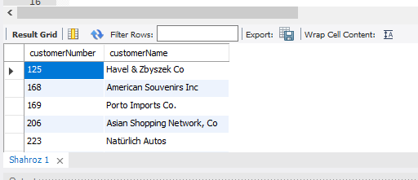

#2.>>>>>>>>>>>>>>>>>>>>>>>>>>>>>>>>>>>>>>>>>>>>>>>>>>>>>>>>>

Create view L1F21BSCS0929 as

Select employeeNumber, concat(firstName, ' ', lastName) as Name

From employees;

Select* from L1F21BSCS0929;

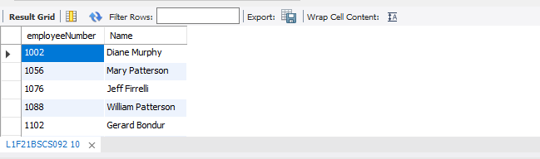

#3.>>>>>>>>>>>>>>>>>>>>>>>>>>>>>>>>>>>>>>>>>>>>>>>>>>>>>>>>>

Alter view L1F21BSCS0929 as

Select employeeNumber, concat(firstName, ' ', lastName) as Name

From employees

Where reportsTo IS NULL;

Select* from L1F21BSCS0929;

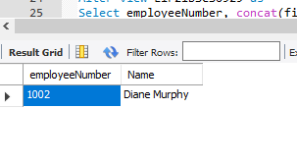

#4.>>>>>>>>>>>>>>>>>>>>>>>>>>>>>>>>>>>>>>>>>>>>>>>>>>>>>>>>>

Create view L0929 as

Select e.employeeNumber, concat(e.firstName, ' ', e.lastName) as Name, o.city

From employees e

Join offices o

On e.officeCode=o.officeCode;

Select* from L0929;

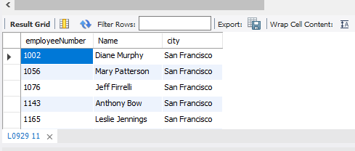

#5.>>>>>>>>>>>>>>>>>>>>>>>>>>>>>>>>>>>>>>>>>>>>>>>>>>>>>>>>>

DROP PROCEDURE IF EXISTS employee_data;

DELIMITER &&

CREATE PROCEDURE employee_data()

BEGIN

SELECT * FROM Employees;

END &&

DELIMITER ;

CALL employee_data();



#6.>>>>>>>>>>>>>>>>>>>>>>>>>>>>>>>>>>>>>>>>>>>>>>>>>>>>>>>>>

DROP PROCEDURE IF EXISTS employee_data_o;

DELIMITER &&

CREATE PROCEDURE employee_data_o()

BEGIN

SELECT e.* FROM Offices AS o

JOIN employees AS e

ON e.officecode = e.officecode;

END &&

DELIMITER ;

CALL employee_data_o();

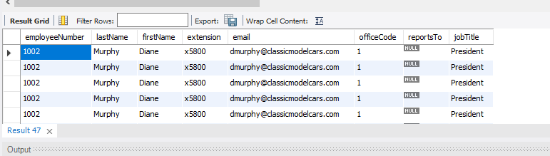

#7.>>>>>>>>>>>>>>>>>>>>>>>>>>>>>>>>>>>>>>>>>>>>>>>>>>>>>>>>>

DROP PROCEDURE IF EXISTS employee_count;

DELIMITER &&

CREATE PROCEDURE employee_count()

BEGIN

SELECT COUNT(e.employeeNumber)

FROM employees AS e

JOIN offices AS o

ON o.officecode = e.officecode

WHERE o.officecode = 6;

END &&

DELIMITER ;

CALL employee_count();

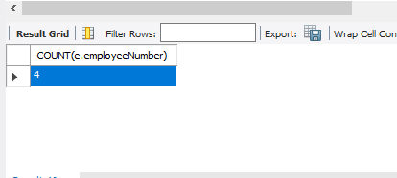

#8.>>>>>>>>>>>>>>>>>>>>>>>>>>>>>>>>>>>>>>>>>>>>>>>>>>>>>>>>>

#9.>>>>>>>>>>>>>>>>>>>>>>>>>>>>>>>>>>>>>>>>>>>>>>>>>>>>>>>>>

DROP VIEW l0929;

DROP PROCEDURE employee_count;

#10.>>>>>>>>>>>>>>>>>>>>>>>>>>>>>>>>>>>>>>>>>>>>>>>>>>>>>>>>>